###### ****How best to tackle plant names?****

Recognising the actual plants in gardens is your best method of revision, but where this isn't possible, the pictures on the site should give you a good range of views of each plant - overall shape, flower/leaf, etc.

You can also use other websites which give good images and information on plants, e.g. www.wildchicken.com (<http://www.wildchicken.com/nature/garden/nature_200_plant_info.htm>) to practise.

* Some students find making **'keycards'** for each plant, with pictures and one side, names and facts on the other, are a great help in learning names. Keep them where you can practise in a few spare minutes every day - in your bag if you commute on public transport, in the bathroom at home....
* [www.cram.com](https://www.cram.com/) is a free site that lets you create flashcards to test yourself using your phone; one of our weekly students in 2015/16 created a set for himself which he shared as 'BEST practical horticulture level 2 2015 -16'. If this works for you, make your own revision cards.
* **Spelling is not critical at level 2**: at your assessment you will be given an alphabetical index of all the plants on the RHS list, and you can use this to refer to. At level 3 you will need to spell the names by yourself and also give more information about the plants.
* **If you are not studying the theory units** **and are new to the use of botanical names**, you may find the presentation on plant names and classification below is helpful. It is part of the first theory unit in the Plant Growth Certificate and tells you a little about why the binomial system (two names, Genus and species) is used, and how to follow the conventions in writing and using names.
* Below is a list of books which you may find interesting or useful .

|  |  |  |  |
| --- | --- | --- | --- |
|  | |  | | --- | | [Plant Names Simplified: Their Pronunciation, Derivation & Meaning:](http://www.amazon.co.uk/Plant-Names-Simplified-Pronunciation-Derivation/dp/0900513047/ref=sr_1_1?ie=UTF8&s=books&qid=1202237111&sr=1-1)  by Arthur T. Johnson and H.A. Smith (Paperback - Nov 1972) | |  | |
|  | [RHS Latin for Gardeners: Over 3,000 Plant Names Explained and Explored: More than 1,500 Essential Plant Names and the Secrets They Contain](https://www.amazon.co.uk/RHS-Latin-Gardeners-Explained-Explored/dp/184533731X/ref=pd_sbs_14_7?_encoding=UTF8&pd_rd_i=184533731X&pd_rd_r=5808b98f-8e17-4654-b9e5-5ff8b2e8dbff&pd_rd_w=GodcY&pd_rd_wg=n0Eiv&pf_rd_p=4fd38ebe-c6e0-49c6-9586-ee7ede565afb&pf_rd_r=EETWWYE6CRW3GC6F1Z7C&psc=1&refRID=EETWWYE6CRW3GC6F1Z7C) by by Royal Horticultural Society (Author), Lorraine Harrison (Hardcover – 1 Oct. 2012) |
|  | |  | | --- | | [Stearn's Dictionary of Plant Names for Gardeners: A Handbook on the Origin and Meaning of the Botanical Names of Some Cultivated Plants](http://www.amazon.co.uk/Stearns-Dictionary-Plant-Names-Gardeners/dp/030436469X/ref=sr_1_3?ie=UTF8&s=books&qid=1202237111&sr=1-3) by William T. Stearn, Brent Elliot, and Isadore L.L. Smith (Hardcover - 10 Oct 2002) | |  | |
|  | |  | | --- | | [A Gardener's Handbook of Plant Names: Their Meanings and Origins](http://www.amazon.co.uk/Gardeners-Handbook-Plant-Names-Meanings/dp/0486297152/ref=sr_1_6?ie=UTF8&s=books&qid=1202237111&sr=1-6) by A.W. Smith (Paperback - 21 Sep 1997) | |  | |
|  | [**Name That Plant: An Illustrated Guide**](http://www.amazon.co.uk/Name-That-Plant-Illustrated-Guide/dp/1903025710/ref=pd_sim_b_3) by Martin Page ( **Paperback** -  2008) |
|  | [**Horticulture: Plant Names Explained: Botanical Terms and Their Meaning**](http://www.amazon.co.uk/Horticulture-Plant-Explained-Botanical-Meaning/dp/1558707476/ref=sr_1_5?ie=UTF8&s=books&qid=1222300950&sr=1-5)by William Stearn and Editors At Horticulture (**Paperback** - May 2005) |
|  | [**The Naming of Names: The Search for Order in the World of Plants**](http://www.amazon.co.uk/Naming-Names-Search-Order-Plants/dp/0747582440/ref=sr_1_4?ie=UTF8&s=books&qid=1222300568&sr=8-4)by Anna Pavord (**Paperback** - 1 Oct 2007) |

**Flash cards:**

Two ways of creating flashcards that may be useful if you want a high-tech solution:

**https://quizlet.com**



And

[**www.cram.com**](http://www.cram.com)

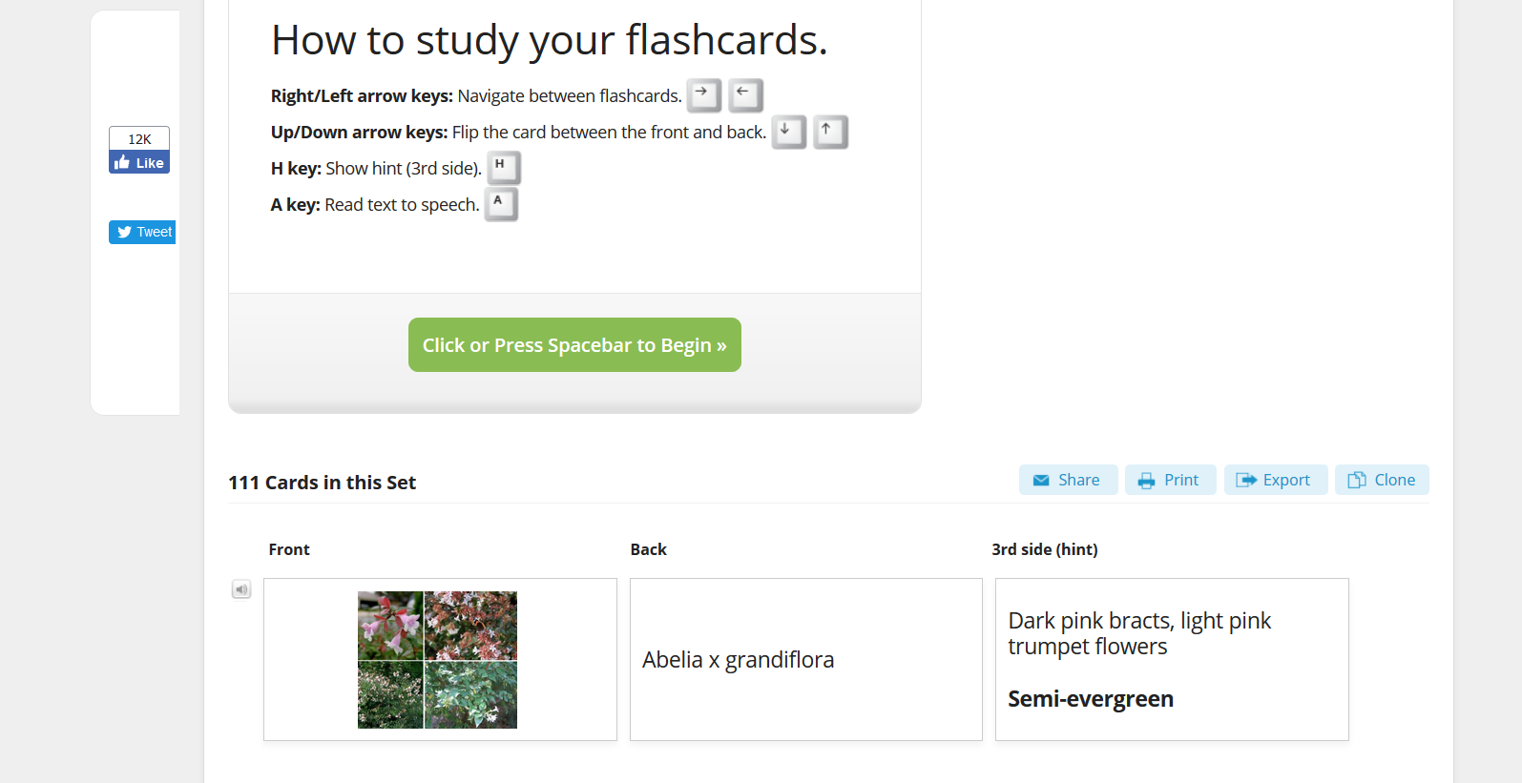

In both cases you will find there are some card sets already created and publicly shared which you can use, but much of the learning benefit will come from making your own cards.

(Don’t search for ‘RHS‘ as it takes you to radiography and other technical studies.)