**How to select your exam sitting**

Go into the Unit you want to take the exam for i.e. Unit 1 or Unit 2. As you scroll down you will see an option to ‘Choose when you want to sit your exam for this unit’.

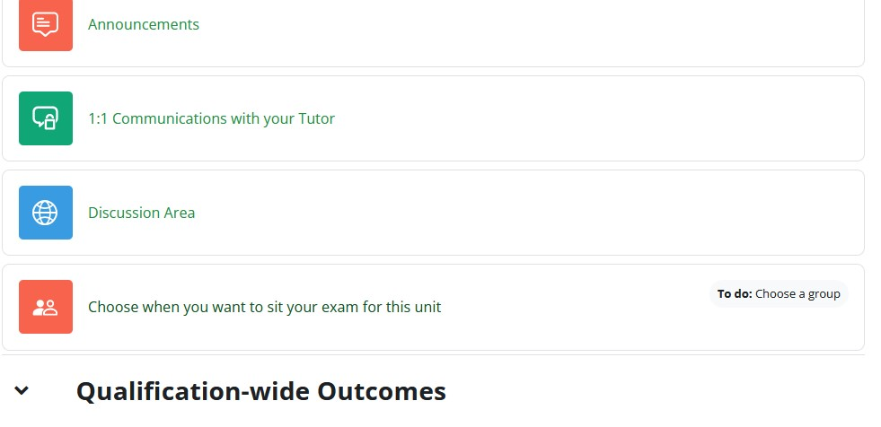

Select this option. The page below will then be displayed. Select the exam sitting you want and click the ‘Save my choice’ button. Your exam sitting choice will then be saved for you.

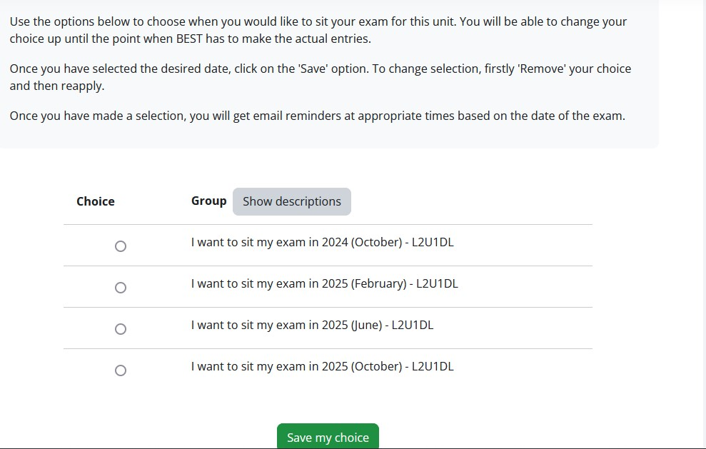

Changes can be made until the closing date for each specific exam sitting.